Hell For One

Gameplay type: Free

Introduction:
“Hell For One” is a strategical hack and slash game in which you are an entire horde of little demons. You directly control only one of them, while the others will follow your orders. When the demon you’re controlling dies, you will immediately play as another member of the horde, until the horde is completely extinguished.
Expand your army, slay whoever gets in your way and guide your fellow rebels in a civil war against the demon lord!

Background:
Long ago, the demons invaded the world of the mortals. But their divinities protected them, sealing the invaders’ lord into the depths of hell, forcing the whole army to retire. The seal on the demon lord would have lasted 10.000 years, so he started to patiently wait. Nowadays a small group of the lowest-class demons, sick of a life without mortals to slaughter, have decided to rebel, kill their lord and finally guide a new invasion with all the demons under their command.

Description:
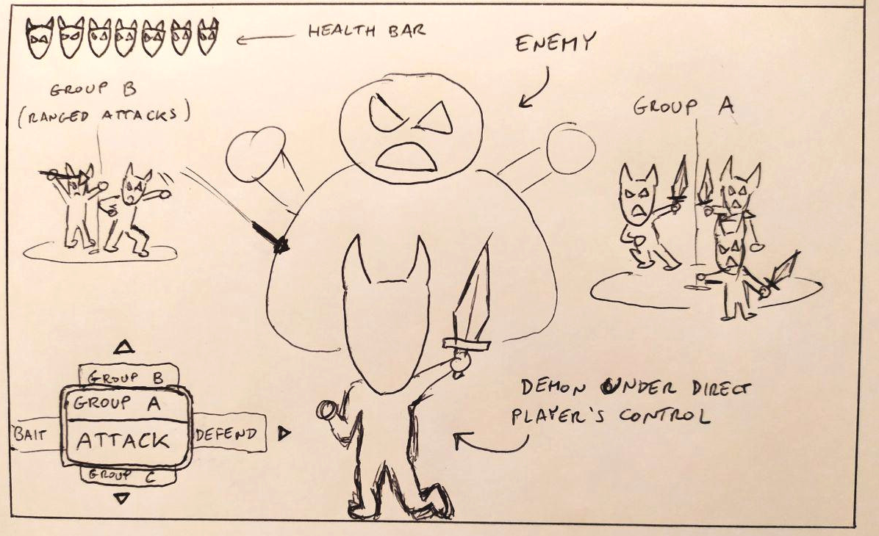
How the horde works more in detail: you can divide the horde into little groups and give to each of them more specific orders (attack, bait, support...) through shortcuts previously assigned in the menu, and build the horde as you prefer.
Player’s life is indicated by the remaining number of members in the horde (see the upper-left part of the concept “““art”””). Every member is very weak and dies quite easily if receives a direct hit. All the demons that you don’t directly control will have blocking and dodging capabilities depending on the orders given to them. An “attacking” group of demons for example will be vulnerable.
The horde continuously “regenerate” itself with a new unit after a given amount of time: the nearby demons that are watching the horde rebelling against their lord will eventually find the courage to join you (and become cannon fodder).

Key Features:
- “Immediate reincarnation” mechanic: if you die, you’re instantly thrown back in the fight inside another demon.
- A story based only on evil characters: see the things from an unusual point of view.
- An atypical combination between action and strategy: kill everything that moves, but guide your horde wisely.
- The horde-building as a central component: choose the demons that you prefer and organize them to optimize your battle strategies.
- An aggressive music and art style, with an original UI focused not on a single character but on an entire horde.

Genre: Hack and Slash with some RTS mechanics.

Platform: PC (initial platform), then Consoles.

Analysis of the Competitors:
Some famous games where you control a group of minions or where you fight surrounded by many weak allies are Overlord, Pikmin and For Honor. The “immediate reincarnation” mechanic though it’s kinda unique, and gives to this type of games a whole new layer of planning during combat.

Togliere libertà build e fare per forza 4 gruppi?
17 demoni = 1 da solo + 4 gruppi da 4?
Boss ci mettono molto a cambiare target.
Combattimenti partono in determinati punti script
I gruppi si piazzano in un punto casuale all’interno del primo anello intorno al boss se melee o tank, secondo anello se support o ranged.
Target del nemico chiaramente visibile tramite un indicatore tipo cerchietto rosso ai piedi.
Danni a schermo no, barra vita nemici grossi, barra “crisi”
crisi aumenta coi danni consecutivi, scende col tempo.
Buff sono cumulativi e danno il 40% in attacco, prob. Scudata.
Punteggi aggro non si vedono.
In basso a destra 4 icone che indicano cosa stanno facendo I 4 gruppi.
Forza, valore buff ecc. Di ogni gruppo dipende da quanti demoni ci sono dentro.
Indicatori vita sono faccia/icona del demone. Sono tanti quanti sono I demoni rimasti, alla zelda. I demoni muoiono in due colpi, dopo un colpo l’icona si dimezza tipo I cuoricini di zelda. La tua faccina è più grossa o evidenziata.
Cerchietto blu ai piedi di quello che controlli.
A fine combattimento, I demoni si riequilibrano I gruppi.
Fuori dal combattimento ti seguono come gruppetti.

GROUP ORDERS
- Melee attack (low defense, high damage, aggro proportionate to damage dealt)
- ranged attack (low defense, low damage, aggro proportionate to damage dealt)
- tank (provokes) (high defense, no damage, high fixed aggro)
- support (buff) (medium defense, no damage, medium fixed aggro)

PLAYER ACTIONS
- melee attack (quad) (raises aggro points)
- ranged attack (tri) (raises aggro points a little bit less)
- roll (cerc) (if performed at the right time makes you avoid all the damage)
- block (L1) (reduces the damage taken)
- confirm single order (X) (every time an order changes, the demon shouts. this raises a bit the aggro points)
- lock (R3) a una certa distanza il lock si perde

ANIMAZIONI IMPORTANTI

DEMONI:
- idle
- corsa
- affondo picca (da fermo ed in corsa)
- scudo alzato (da fermo ed in corsa)
- lancia picca (da fermo ed in corsa)
- balletto di supporto
- colpo subito (caduta all’indietro) → esplosione in poltiglia o rialzo

BOSS:
- idle
- movimento
- attacco 1
- attacco 2
- attacco 3
- idle stunnato → si riprende

SUONI DI GIOCO
- affondo picca a vuoto
- affondo picca su carne
- rumore attacco boss
- sblortch piccolo e grosso
- voce per ogni ordine
- colonna sonora, vocine che combattono, vocine che incitano

SCRIPT LIVELLO:
- percorso vuoto, parti con 13 diavoli (1+3+3+3+3)
- piccolo gruppo di diavoletti come te che urlano “uccidete I traditori!”. Morirete di sicuro contro tizio stupido.
- altro percorsino vuoto, alcuni diavoletti si uniscono (cap 13)
- stanza con nemico stupido che attacca solo un gruppo, e a metà vita cambia target, ogni tanto fa l’attacco caricata (“ahia, chi è stato?”)
- nuove unità che si uniscono impressionate (fino al cap di 1+4+4+4+4)
- corridoio
- boss singolo, dialogo finale.

“Hell For One” is a single player hack and slash with some real time strategy elements.

You are an entire horde of little demons, but you directly control only one of them at a time.

With the demon you’re controlling you can fight by attacking, blocking and dodging.

The other demons of the horde are divided by you into little groups. You have to give orders to groups like attack, defend or bait the enemy. (Think about some jrpgs with atb bars like final fantasy xiii or the ffvii remake, but instead of party members you have small groups of demons).

When the demon you control dies, you will immediately take control of another demon of the horde, and you lose when the horde is completely extinguished.

